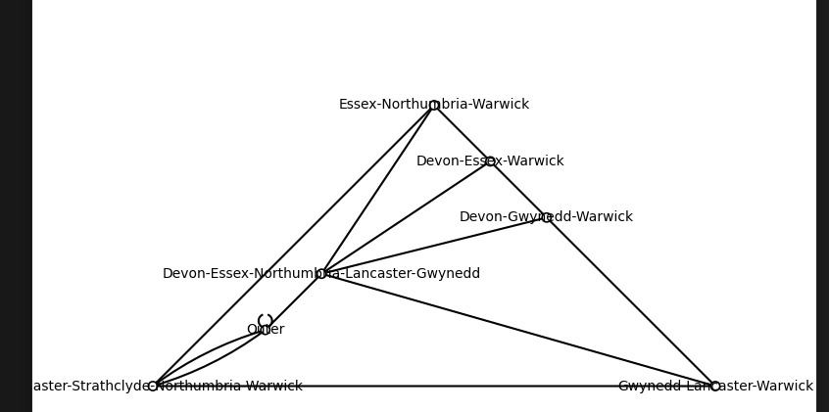
Warwick
Moray
Strathclyde
Northumbria
Essex
Lancaster
Gwynedd
Devon

